# 发布相关

## 不用codesign也可以编译输出 （在general中只设置了allToOne,team自动填了， 但是在unity中只是allToOne不会自动设置teamid导致编译不通过）

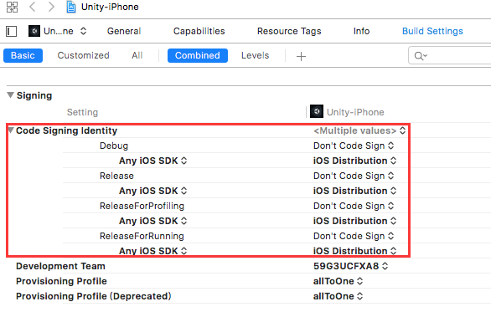

warning: PackageApplication is deprecated, use `xcodebuild -exportArchive` instead.

## 编译xcode输出ipa 1

* xcodebuild CFLAGS=“$MYFLAG” -sdk iphoneos -project /Users/Shared/Jenkins/Home/workspace/MyTestProject/proj_ios/Unity-iPhone.xcodeproj -configuration Release -jobs 8 PROVISIONING_PROFILE=“” [** xcode9.2ok **][需提前把证书profile设置好]
* xcrun -sdk iphoneos PackageApplication -v /Users/Shared/Jenkins/Home/workspace/MyTestProject/proj_ios/build/Release-iphoneos/ztzsnew.app -o ~/Desktop/gamenormal.ipa [** xcode9.2ok **]

## 编译xcode输出ipa 2

* Xcode手动build🡪archive
* xcodebuild -exportArchive -archivePath /Users/Shared/Jenkins/Library/Developer/Xcode/Archives/2018-08-08/Unity-iPhone\ 2018-8-8\ 上午8.29.xcarchive -exportPath ~/Desktop/game3.ipa -exportOptionsPlist /Users/Shared/Jenkins/Home/workspace/MyTestProject/info.plist [** xcode9.2ok **]

## 编译xcode输出ipa 3 （广益 Unity中去掉autosign）

编译

xcodebuild -project /Users/Shared/Jenkins/Home/workspace/MyTestProject/Assets/../proj_ios/Unity-iPhone.xcodeproj archive -scheme Unity-iPhone -destination generic/platform=iOS PROVISIONING_PROFILE_SPECIFIER=allToOne CODE_SIGN_IDENTITY="iPhone Distribution: Shanghai Giant Network Technology Co., Ltd." -archivePath ~/Desktop/Unity-iPhone.xcarchive

[** xcode9.2ok **]

生成

xcodebuild -exportArchive -archivePath ~/Desktop/Unity-iPhone.xcarchive -exportPath ~/Desktop/gameoutput -exportOptionsPlist ~/Desktop/info.plist [** xcode9.2ok **]

## jsb Jenkins <http://192.168.93.253:8080/> laoguai 1q..

## 原jenkins脚本备份（需要手动设置证书。。。）

security unlock-keychain -p "123456@a" "/Users/Shared/Jenkins/Library/Keychains/login.keychain"

xcodebuild -target Unity-iPhone -verbose -configuration Release CODE_SIGN_IDENTITY="iPhone Distribution: Shanghai Giant Network Technology Co., Ltd." -jobs 8 -project /Users/Shared/Jenkins/Home/workspace/MyTestProject/Assets/../proj_ios/Unity-iPhone.xcodeproj

xcrun -sdk iphoneos PackageApplication -v /Users/Shared/Jenkins/Home/workspace/MyTestProject/Assets/../proj_ios/build/Release-iphoneos/ztzsnew.app -o ~/Desktop/hello.ipa

## Profile

"Provisioning profile "ztzsnewDis" is not an "iOS In House" profile.

## Export plist

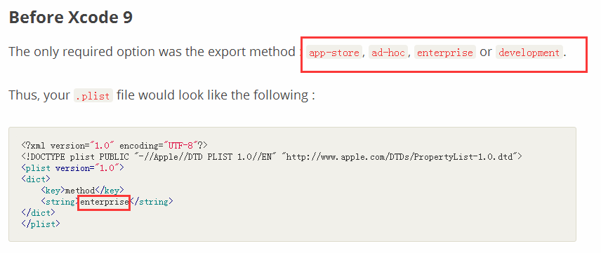

<https://warchimede.github.io/2017/10/05/export-xcarchive-to-ipa-xcodebuild-xcode-9/>

**After Xcode 9**

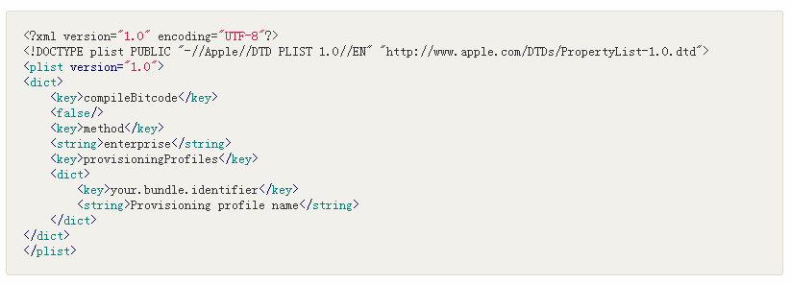

## 创建证书到发布上传

<https://blog.csdn.net/liuxiongtao_1124/article/details/72373800>

# jsb Jenkins

## unity->xcode

**Unity**

-quit -batchmode -executeMethod GameBox.Service.AssetManager.Package.OnCommand platform:9 bundleOptions:256 targetPath:GameBox.Output/AssetManager/iOS bundleExtension:.ab keepFolders:GameBox ignoreFolders:Unpack version:${VERSION}.${BUILD_NUMBER}.${SVN_REVISION}

**Shell**

【GXPack】增加Unity版本

**Unity**

-quit -batchmode -executeMethod GameBox.Framework.Build.OnCommand platform:9 project:iOS version:${VERSION} build:${BUILD_NUMBER}

**Shell**

#!/bin/bash

projPath=$PWD/iOS

binPath=$projPath/build/bin

xcodebuild -project $projPath/Unity-iPhone.xcodeproj archive -scheme Unity-iPhone -destination generic/platform=iOS PROVISIONING_PROFILE_SPECIFIER=ztappInHouse CODE_SIGN_IDENTITY="iPhone Distribution: shanghai Giant Tongping Network Technology Co., Ltd." -archivePath $binPath/Unity-iPhone.xcarchive

xcodebuild -exportArchive -archivePath $binPath/Unity-iPhone.xcarchive -exportPath $binPath/ -exportOptionsPlist $PWD/build.plist

mv $binPath/Unity-iPhone.ipa $PWD/ztfreeapp.v${VERSION}.${BUILD_NUMBER}.r${SVN_REVISION}.ipa

||

V

